**GDS-2074A GW INSTEK**

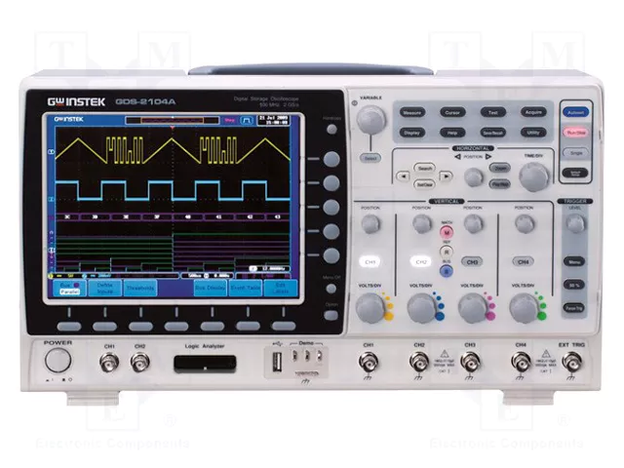

|  |  |
| --- | --- |
| Url | https://www.tme.eu/en/details/gds-2074a/digital-oscilloscopes/gw-instek/ |
| Video | https://www.youtube.com/watch?v=0tY0-CzIesY |

**Features:**  
- 300MHz/200MHz/100MHz/70MHz Bandwidth, 2 or 4 Input Channel  
- 2GSa/s Real-time Sampling Rate and 100GSa/s Equivalent Time Sampling Rate  
- 2Mega Points Record Length  
- 1mV /div to 10V/div of Vertical Range  
- 1ns/div to 100s/div of Time Base Range  
- 80,000 wfm/s of Waveform Update Rate  
- 8 inch 800*600 High Resolution TFT LCD Display  
- Built-in Segmented Memory and Waveform Search Functions to Optimize the Efficiency of Record Length  
- Zoom Window and Play/Pause can Rapidly Navigate the Waveforms  
- 36 Automatic Measurement Functions Offers Various Measurement Selections  
- Optional 8 or 16 digital channel with Logic analyzer (MSO)  
- Optional Function Generator  
- Flexible Remote Control Connectivity (Standard: USB; Option: LAN)  
- Upgradable CAN/LIN bus analysis, Advanced Logic, Datalog, DVM and H-expansion functionalities  
  
**2GSa/s Real-time Sampling Rate and up to 300MHz Bandwidth**  
GDS-2000A Series Digital Storage Oscilloscope offers 2 and 4-channel configurations and wide bandwidth selections, including 300MHz, 200MHz, 100MHz and 70MHz. Each model provides 2GSa/s maximum real-time sampling rate and 100GSa/s high-speed equivalent-time sampling rate. Equipped with an 8-inch 800 x 600 high-resolution TFT LCD display, 1mV/div to 10V/div vertical range and 1ns/div to 100s/div time base, the GDS-2000A Series is able to faithfully demonstrate waveforms of complicated and obscure signals.  
  
**2Mega Point Record Length, Waveform Search and Segmented Memory Functions**  
The GDS-2000A Series provides 2Mega point record length, and Waveform Search and Segmented Memory functions as standard features. The events of interest can be captured and saved into the Segmented Memory, which can be divided into 2048 sections, for observation, while the irrelevant waveforms can be ignored. Consequently, the overall efficiency of memory usage can be enhanced. Under Waveform Search mode, after the input signal is triggered, the GDS-2000A Series is able to Search and Mark the waveform sections, which comply with user-defined search condition and threshold level within the whole memory. Meanwhile, with Zoom window and Play/Pause button to scroll through whole displayed waveform, the user can rapidly navigate all the waveforms in an efficient way.  
  
**Accessory**  
User Manual CD x1, Power Code x1  
GTP-070B-4 70MHz (10:1/1:1) Switchable passive probe for GDS-2072A/2074A (One per channel)  
GTP-150A-2 150MHz (10:1/1:1) Switchable passive probe for GDS-2102A/2104A (One per channel)  
GTP-250A-2 250MHz (10:1/1:1) Switchable passive probe for GDS-2202A/2204A (One per channel)  
GTP-350A-2 350MHz (10:1/1:1) Switchable passive probe for GDS-2302A/2304A (One per channel)  
  
**Optional**  
DS2-LAN Ethernet & SVGA output  
DS2-FGN DDS Function Generator  
AFG-125 25MHz Single channel USB Modular Arbitrary Function Generator  
AFG-225 25MHz Dual channel USB Modular Arbitrary Function Generator  
DS2-16LA 16-Channel Logic Analyzer includes, 16 Channel Logic Analyzer Card (GLA-16), 16-Channel Logic Analyzer Probe (GTL-16LA)  
DS2-08LA 8-Channel Logic Analyzer : includes, 8-Channel Logic Analyzer Card (GLA-08), 8-Channel Logic Analyzer Probe (GTL-08LA)  
  
**Optional Accessories**  
GTL-08LA 8-Channel Logic Analyzer Probe  
GTL-16LA 16-Channel Logic Analyzer Probe  
GLA-08 8-Channel Logic Analyzer Card  
GLA-16 16-Channel Logic Analyzer Card  
GRA-420 Rack Adapter Panel  
GAK-003 50Ω Impedance Adapter  
DS2-FH1 Module extension bay & USB Type A to Type A/B cable  
GSC-008 Soft Carrying Case  
GTL-232 RS-232C Cable, 9-pin, F-F Type, null modem, 2000mm  
GTL-246 USB Cable, USB 2.0, A-B Type, 1200mm  
GDB-03 Oscilloscope Education & Training Kit  
GCP-005 Current Probe, 40Hz ~ 1kHz, 5A, Current Probe  
GCP-020 Current Probe, DC ~ 100KHz, 10A, Current Probe  
GCP-100 Current Probe, 40Hz ~ 10KHz, 20A, Current Probe  
GCP-1030 Current Probe, DC ~ 100MHz, 30Arms, Current probe  
GCP-206P Current Probe - Power Supply, 2 Channel Power Supply for GCP-530/1030  
GCP-245P Current Probe - Power Supply, 4 Channel Power Supply for GCP-530/1030  
GCP-530 Current Probe, DC ~ 50MHz, 30Arms, Current Probe  
GDP-025 Differential Probe, 25M High Voltage Differntial Probe  
GDP-050 Differential Probe, 50M High Voltage Differntial Probe  
GDP-100 Differential Probe, 100M High Voltage Differntial Probe  
GTP-033A Oscilloscope Probe, 35MHz 1:1 Passive Probe, BNC(P/M)